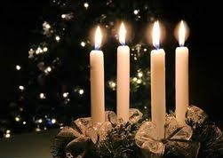
CROSSGATES METHODIST CHURCH Dec & Jan 2023/4 Newsletter
MINISTER: Rev Becki Stennett

…And this was the moment
When a few farm workers and three
Members of an obscure Persian sect
Walked haphazard by starlight straight
Into the kingdom of heaven.
(U.A. Fanthorpe)
I hope you’re feeling Christmassy by now! Not everyone enjoys the now seemingly super early Christmas preparations made in shops and other places, which some even as summer ends now I think, but by December, I think it’s fair game to start feeling a little excited.
I love all of the Christmas lights brightening the darkness, and the strains of cheerful Christmas music pouring out of cafes and shops, and I love the sense of Christmas celebrations slowly creeping in to my work and home life.
But for some of us, that feeling of Christmas drawing near may bring a sense of dread, or fear. For some of us, it comes with a sense of almost overwhelming anxiety. Perhaps we’re anticipating Christmas being lonely, or difficult, for one reason or another. Perhaps we’re anticipating not finishing all our preparations to the standards we think ought to be met by the time expected.
A time that should bring great joy, in these cases and others, may sour and become a season that feels burdensome, and one we’re wishing will pass swiftly.
These words from U.A. Fanthorpe’s poem ‘BC:AD’ are some of my favourite for refocussing, and reengaging with what the heart of Christmas is all about.
We’re reintroduced in these closing lines to shepherds and magi, who visit the infant Jesus, and we’re reminded that, for them, it all felt a bit unlikely, a bit ‘go with the flow but we’re not exactly sure what’s happening’, a bit ‘haphazard’.
Taking the wide view, we know that these shepherds and the magi who travel from a great distance to meet Jesus are not there ‘haphazardly’ at all. There is no chance or coincidence here. Rather, God has offered an invitation, by angel song or star light, to some unexpected, ordinary and exotic folk, and they have responded to the invitation and come across heaven on earth.
The same may be true for each of us this Christmas time, regardless of how we feel about the glitz and sparkle of the season. We are each invited to come and know something of heaven on earth, God coming close to us all. The invitation may not now come with a choir of angels singing, or a star moving across the sky, but perhaps we might perceive it in new and unexpected ways, as we see the lights and food and figures of the modern Christmas, remembering that each of these may eventually point us to the love and light and joy of the Christ child.
It may feel haphazard, the possibility that Christmas, true, Christ-mas may emerge from the twinkling and tinselling, but each bell and bead and pine needle are gifts to remind us that God sent Jesus that we might have great joy, deep peace, and eternal hope.
Whether you greet the season with joy or dread, be assured that you are not walking into it without purpose, unloved. Instead, you are invited by God to get to know heaven through Jesus, who comes so simply, so quietly, indeed without any of the right preparations that would usually made.
Nothing would stop Jesus coming to us then, and Jesus will break through with heavensong now, if we’re ready to open the door to our hearts just a little. Rev Becki

Churches Together in East Leeds
Everyone is invited on Advent Sunday 3rd December to join other Churches in our area, at Christ Church Halton. The Advent Service starts at 4.0pm. Come and meet with members of other Churches, as we begin together to remember and celebrate the birth of Jesus.

Coffee & Carols at Christchurch Halton
All welcome on Saturday 16th December 10am to 11.30am. Led by Concordia with donations to Macmillan Cancer Care.

Services in December 2023
3rd December | 10.30am |  | Mrs Janet Green
10th December | 10.30am |  | Mr Michael Prince
17th December | 10.30am | Holy Communion | Revd Becki Stennett
17th December | 4pm | Carol Service | Revd Norma Davey
23rd December | 11am | Carols on Church steps
24th December | 10.30am |  | Revd George Bailey
24th December | 4pm | Children’s Crib Service | Mr Andy Birkett
24th December | 11.30pm | Holy Communion | Revd Becki Stennett
25th December | 9.30am |  | Revd Joyce Nicholson
31st December | 10.30am |  | Revd Becki Stennett

The communion stewards for December are Barbara Lloyd & John Blyth

Carols in the Park
Join the community for carols in Manston Park on Saturday 23rd December 6.30pm – 7pm. Community singing followed by mulled wine and mince pies. (organised by Connecting Crossgates). Please take a torch or lantern. Everyone welcome.
Ladies Friendship Group
Meetings are on the second and fourth Tuesdays of the month at 2.30pm in the Wesley Room. All welcome.
28th November – Advent with Revd Becki Stennett
12th December – Christmas carols and songs (jointly with Men’s Fellowship)
19th December – Christmas lunch
Thank you from British Red Cross
‘Thank you for forwarding to us the donations totalling £348.25 for the British Red Cross Libya Floods Appeal. Right now, the Libyan Red Crescent is helping deliver vital aid to survivors in the flooded areas and is supporting with rescue efforts. This includes first aid and medical assistance, search and rescue, evacuating families, provision of food, water, emergency shelter kits and other relief items. Your generous donation will make a real difference to people in their hour of need.’

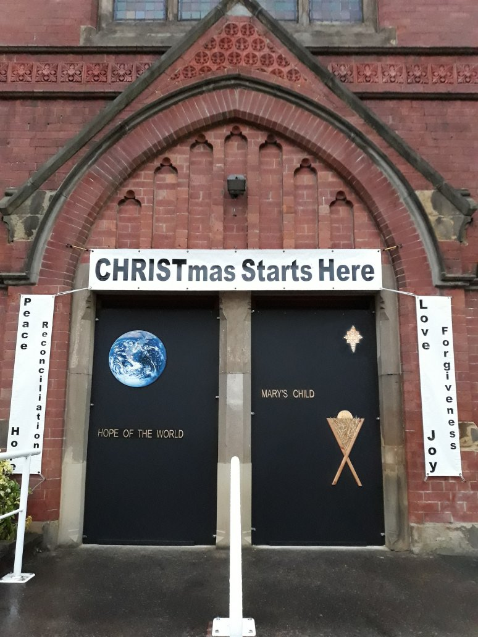
Christmas Greetings
Wishing everyone a peaceful Christmas and a happy and healthy 2024. Tracy, Aleck and Jessica Dick
To the Church Family – best wishes for a very Happy Christmas and a healthy and peaceful New Year from Shirley Clough.
Wishing all our friends at Cross Gates a very happy and peaceful Christmas and New Year. Margaret & Geoff Yapp

Dorothy and Alan Tate wish the Church family a happy Christmas and a healthy New Year.
Cedric and Lynda send Christmas Greetings to all the Church Family and wish everyone a very Happy and Peaceful 2024.
John and Cynthia Best wish all their Church family a Peaceful and Healthy Christmas and New Year.
Wishing the Church family a very Happy Christmas and a peaceful New Year. Love from Jean Drake.
Christmas Greetings to my friends at Church from Pauline Brown.
Carol, John and Neil Smith would like to wish everyone in our Church family a Merry Christmas and a Peaceful, Happy and Healthy New Year. xxx
Wishing all the Church family a wonderful Christmas and a happy new year. Best wishes from Denise and Mick Durkin.
Wishing the Church family a Happy Christmas and healthy New Year, Amanda Brow
Wishing everyone a happy and peaceful Christmas and a healthy New Year. Lots of love, Jane and Holly. X x
Barbara and Michael Lloyd, wish all our Church family a joyous Christmas and a happy and peaceful 2024
Wishing our lovely Revd Becki Stennett and all her family and all my church family a very happy and blessed Christmas to each one of you.
May your hearts be filled with love, joy and peace this Christmas and always. Love June Holliday.

Georgina and Roy Cressey wish all the church family a happy and peaceful Christmas and a very happy new year.

Love and Best Wishes from Beryl Gledhill at this special time Christmas and for the coming year.
Merry Christmas and best wishes for the New Year to all at Cross Gates and Seacroft from Jenny Reeve.
Best wishes for a Happy Christmas to all the Church family from Christine and Richard Holdstock
Wishing all the Church family a very happy Christmas and wishing you all a peaceful and healthy New Year. Love and best wishes from Joan Chorley
We would like to wish the Church family a very happy Christmas and a peaceful New Year. Keith and Deborah
(Please forgive any errors or omissions in the greetings)
Leeds South & East Foodbank (Trussell Trust)
helping local people in crisis
In October we delivered 11 baskets (142 Kg) to South Leeds Trussel Trust Distribution Centre. As we approach Christmas the number of families using the Food Banks in our area continues to grow.
Wouldn't it be nice if every child could receive a small gift - perhaps a bar of chocolate? Across the UK, 65% of all parcels were provided to families with children.
There is a basket for your gifts in the Galilee or John Best. email jvbest39@hotmail.com who will gladly collect.

Services in January 2024
(In the Church Hall)
7th January | 10.30am |  | Mr David Laycock
14th January | 10.30am |  | Revd Harry Jones
14th January | 4pm | Memorial Service | Revd Becki Stennett
21st January | 10.30am | Covenant Service | Revd Becki Stennett
28th January | 10.30am |  | Mrs Hazel Featherstone
We are planning that like last year services in the coldest months – January to March - will be taking place in the Church Hall rather than the Church itself. This is in order to save money on heating costs whilst ensuring we all stay warm.

Church Flowers
Flowers on Remembrance Sunday were donated by Carol Smith in memory of John’s and Carol's mums’ birthdays. The small one in the entrance were from the flower fund kitty.
Flowers for 19th November were donated by Keith Tingle, Deborah and Beverley in memory of Jean.
Margaret Saysel and her brother donated flowers in memory of their Mum and Dad, Barbara and Charles Skinn, their Aunt and Uncle, Margaret and Bryan Rhodes. These will be in Church on 3rd December and Advent.
Flowers at Christmas will be provided by Georgina and Roy Cressey in memory of their families who all passed on at this time of year.
If you would like Flowers to be arranged in Church for a special reason please contact Georgina Cressey or Barbara Leeming.
Donations towards the cost is much appreciated.
Table Top Sales - 3rd February & 2nd March 2024
Come and enjoy a warm drink and a chat with friends and then browse round the items for sale in the Church Hall.
If you would like more information or to book a table, at a cost of £5 for church funds, please contact Lynda at Church or phone 0779 9094472.
Please note, there will not be a sale in December or January.
Thank You…….
……to all those who work so hard to keep our Church running smoothly. It takes a team to achieve so much and we are all very grateful to those who undertake tasks, big and small.
Tracey Martin (Ann Martin’s daughter) gives us an insight into her current role
On a corner of an elegant square in Brussels just round the corner from the European Commission, there is a beautiful Art Nouveau house. This is Quaker House where I now live and work as Director of the Quaker Council for European Affairs.
Our job is to bring Quaker concerns to the European institutions, the EU, the Council of Europe and other bodies. Like Methodists, Quakers have long worked for justice and equality. They are also one of the peace churches and peace is fundamental to my work. Currently we are working to bring a peace perspective to migration and climate justice policy and practice. This means challenging violence at every stage of the migration journey and calling for conflict-sensitive approaches to addressing the climate crisis. For me it is fundamental that the well-being of Europe cannot be built on the suffering of others. That means safe migration routes and not exploiting communities in poorer countries so we have the resources we want to maintain our lifestyles in a fossil-free economy.
But that’s all very high level. What do I do day to day? I go to a lot of meetings! Some of these are very boring and technical, others are inspiring. I may be there to gather information or to put questions or to offer alternatives to potentially harmful policies.
At Quaker House we also offer a space for dialogue where people can explore the pressing issues of the day in a safe space, where people are invited to really listen to those they disagree with and try to look for common ground. To make these events happen we need to build relationships of trust with lots of different people. We sometimes say we should measure our success by the number of cups of coffee we have drunk!

Discussion on the Long Term Circuit Strategy
We are holding a meeting on Sunday 7th January after morning service to discuss the ideas proposed by the Circuit Leadership Team on the long term future of our circuit. A paper which outlines the current situation and the proposed way ahead will be available to read in advance. For those on email it will be sent after Christmas, for others copies will be available from Barbara Lloyd. Please do come along and contribute your thoughts and ideas to this very important discussion about our future. Please bring your own lunch or snacks, tea and coffee will be provided. We look forward to seeing you there. Becki and Barbara.
Condolences: Please remember in your thoughts and prayers the family and friends of Raymond Winders who died on the 14th November in Sunnyside Nursing Home. Raymond had a very strong faith and worshipped with us right up to two weeks before he died.
Date for your diary: the AGM will be held on Sunday 3rd March 2024, after morning service. Everyone is most welcome to attend.
Free phone service to hear prayers and news from the Methodist Church:
Listen to a prayer: 0808 281 2514 and listen to news: 0808 281 2478
Content is updated weekly on a Thursday evening.
Service Options: If there are any people or situations you would like included in the prayers in worship, please let me know by Saturday morning, (having got permission from the individual to be named in our prayers). Please do contact Barbara Lloyd if you would like to receive details of worship via email or would like to have printed worship sheets delivered.
Please remember in your thoughts and prayers: All those people in our prayer book and those we know who are unwell, in hospital, in Nursing Homes, going for tests at Hospital, recently bereaved and who find this time of year particularly difficult.
Your Financial Contributions: Thank you to all those who have continued to contribute to the Church’s running costs. If you do not attend Church, please continue sending them to Linda Booth, or to the Church’s address. Please note cheques are being paid into the bank less frequently now so do not be concerned.
Spotlight On: Please consider writing a few words about your life for inclusion in a future Newsletter, as have many of our Church family already. Please send your contribution to Tracy Dick (contact details below).
Newsletter: Please email contributions for the Newsletter to Tracy Dick tracylouisedick@gmail.com. Deadlines coming up: January 21st 2024, February 18th 2024, Sunday 17th March 2024.
CROSS GATES METHODIST CHURCH MISSION STATEMENT
We are a group of people who are seeking to celebrate and share God’s love for all.
Through Worship, Witness and Service in the Community we aim to follow Christ’s example of open arms, hearts, minds and doors

Cross Gates Methodist Church, Austhorpe Road, Cross Gates, Leeds, LS15 8QR

