A LENT BIBLE STUDY COURSE
Lentwise: Spiritual Essentials for Real Life
As we journey through life, we face challenges - both big and small. What spiritual essentials will help us survive life's storms? Lentwise is a five-session course which helps us to deal with the rigors of real life.
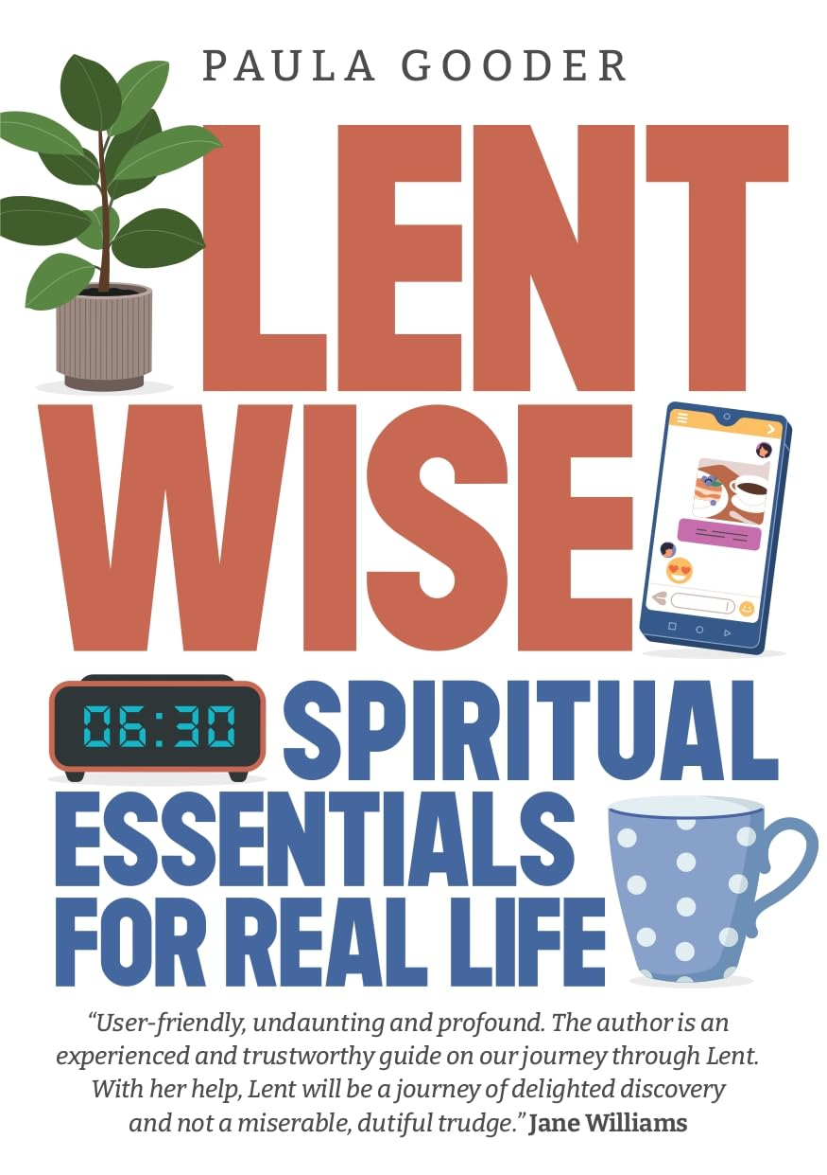
Using fresh insights from John's gospel, it explores: direction, nourishment, wisdom, refreshment, and security.
Shadwell Methodist Church
Tuesdays - 10-11.30am
24th February
11th (please note this is a Wednesday due to Shadwell’s café morning!) 17th, 24th & 31st March

See you there!

